**K8s Quick Overview and Architecture**

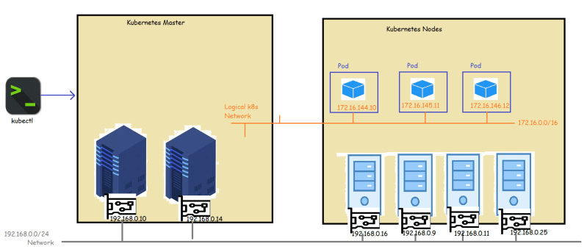

* To create the logical network as shown in the image, Kubernetes has a networking model
* This networking model makes opinionated choices about how Pods are networked.
* K8s dictates the following requirements on any networking implementation
  + all Pods can communicate with all other Pods without using NAT (network address translation)
  + all Nodes can communicate with all Pods without NAT
  + the IP that Pod sees itself is the same IP that others see it as
* Kubernetes defines a specification for configuring network using CNI (Container Network Interface) Link: <https://github.com/containernetworking/cni>
* Example of Kubernetes network.
* Kubernetes network Link: <https://kubernetes.io/docs/concepts/cluster-administration/networking/>

What is NAT? **NAT** allows a single device, such as a router, to act as an agent between the Internet (or public network) and a local network (or private network), which means that only a single unique IP address is required to represent an entire group of computers to anything outside their network.

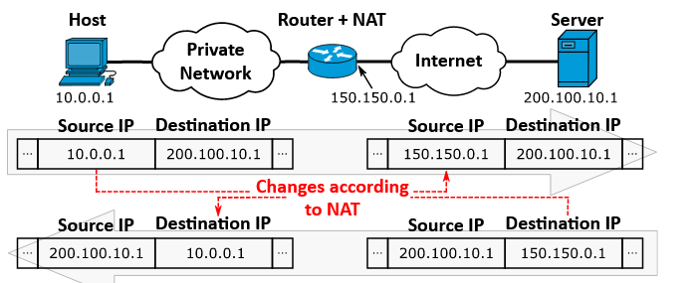

CIDR? Classless Inter-Domain Routing is a method for allocating IP addresses and for IP routing.

Example of Kubernetes network? >> [Calico](https://kubernetes.io/docs/tasks/administer-cluster/network-policy-provider/calico-network-policy/), Weave Net and [Romana](https://kubernetes.io/docs/tasks/administer-cluster/network-policy-provider/romana-network-policy/)